pfileid
File | 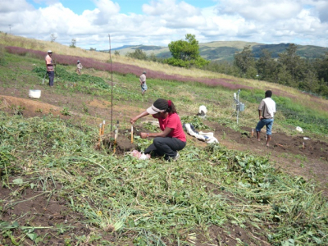
Folder | Foto
Detail
Type | Photo / media
Project | Soil Fertility Management
pfile projectname | Soil fertility management in the PNG Highlands for sweetpotato based cropping systems

