**NARI Milestone Report**

|  |  |
| --- | --- |
| **Project Name** | Mutation Breeding of Banana and Sweet potato |
| **Project Number** | B40325 |
| **Project Leader** | Joel Pilon |
| **Implementing NARI Centres** | Momase Regional Centre |
| **Reporting period** | Jan-March |
| **Date report completed** |  |

1. **Progress towards achievement of the milestones set for the period**

**Milestone 1: Establishing invitro propagation protocol for sweet potato (gumine purple) through thorough invitro investigated experiments.**

* The standard medium for sweet potato invitro multiplication was less effective in multiplication of this cultivar. Invitro propagation issues were further investigated with designed experimental protocol. Designed medium points were generated base on the standard medium but several additives and growth regulators were tested. The activities were centered on improving the multiplication rate base on increased nodal segments in short period of time. It was noted that Gumine purple takes 2-4 months to reach maximum heights for further sub-culture on standard medium. However, with the recent investigated medium; it takes three (3) weeks – four weeks before the next sub-culture ensuring generation of sufficient plantlets in short period of time.

1. First experiments Investigated four different mediums comprising of low BAP level combine with additives.
2. Second experiment investigated the role of vitamins using ‘omission’ method. We omitted vitamins in the presence of PGR or omitted PGR in the presence of Vitamins or Omitting all vitamins except one (myo-inositol). The second experiments relied on the results obtained from the first experiment where we applied factorial design to further investigated shoot apex and nodal segments combine with organics omission.
3. Third experiments on temperature regime were not investigated but further validation with Aiyura TC laboratory could investigated the role of temperature.

* The project may need to repeat the trial once more collective pooled data.

|  |  |  |  |  |  |
| --- | --- | --- | --- | --- | --- |
| **Media Type** | **Days taken for bud breaks** | **Number of nodes/explants** | **Number of roots/explants** | **Number of leaf/explants** | **Callus formation (%)** |
| Media A** | 24.25b | 0.50a | 0.00a | 1.25a | 0.00 |
| Media B | 4.00a | 4.25b | 2.50ab | 3.00a | 0.00 |
| Media C | 29.00c | 4.75b | 1.25a | 1.50a | 90.00 |
| Media D | 4.50a | 1.25a | 5.75b | 2.00a | 0.00 |
| **Mean** | **15.44** | **2.69** | **2.38** | **1.94** | **22.50** |
| ***LSD*** | **1.20** | **1.00** | **4.19** | **2.26** |  |
| ***p-Value*** | **<0.001** | **<0.001** | **0.06** | **0.36** |  |
| ***cv (%)*** |  |  |  |  |  |

, ** Standard Media for sweet potato multiplication

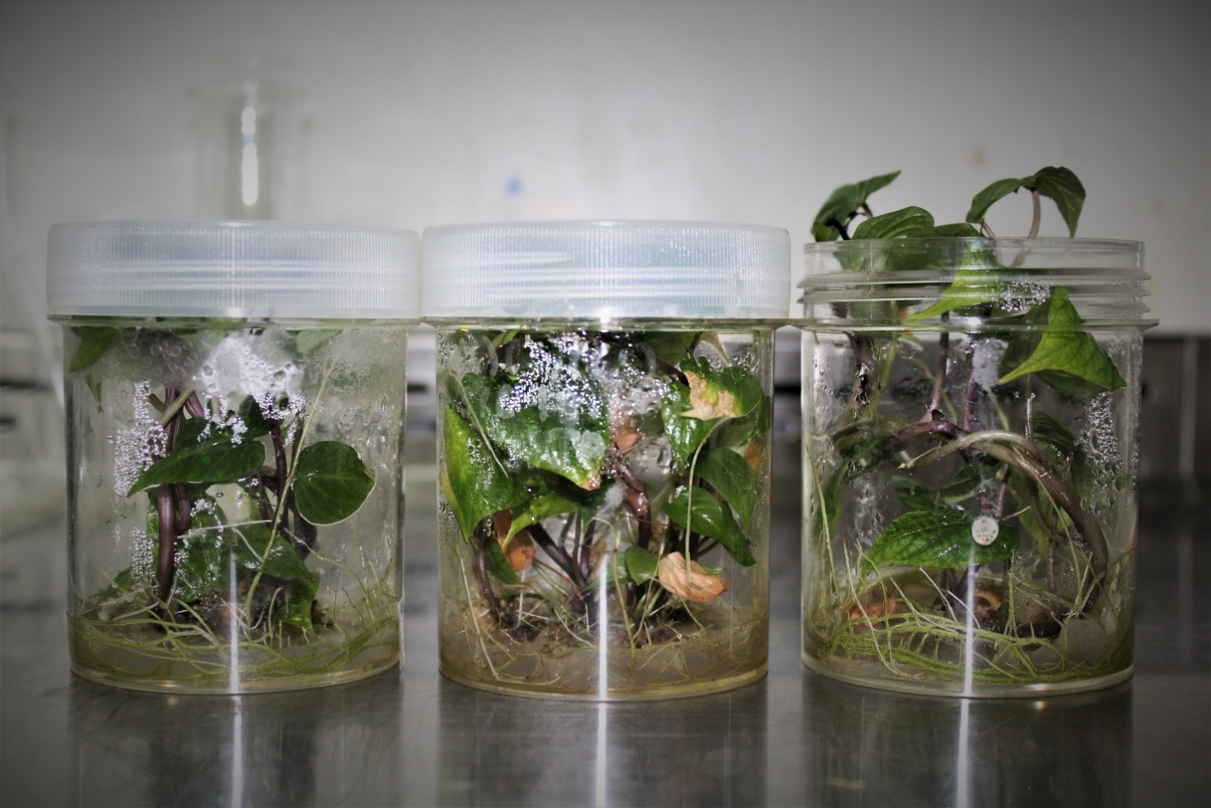

**Milestone 2: Establishing callus mediated protocol for sweet potato**

* Four sweet potatoes were evaluated targeting respective regenerative capacity from mediated leaf-derived callus. The overall aim is to establish protocol which is directly connected with regeneration of ‘single cells’ for mutagenesis in country using EMS. Single cells derived from callus culture (indirect) is of great important for mutation breeding. Moreover, regenerative cells could of target to screen for salinity and drought stresses.

The project found out that not all sweet potato can regenerate from callus culture; it was linked or strongly associated with genotypic effects. Gumine purple regenerate from mediated callus while RAB 36, BSBL 04 and Simat needs further investigation.

1. First experiments investigated different sweet potato parts es explants; i.e leaf, nodes and petiole. Petiole did not response well on the defined medium while leaf and nodes produce good results. However, most of the nodal segment contaminated when transferring from callus induction medium.

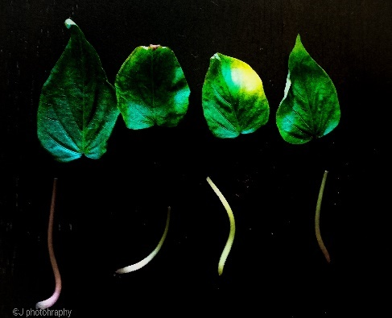 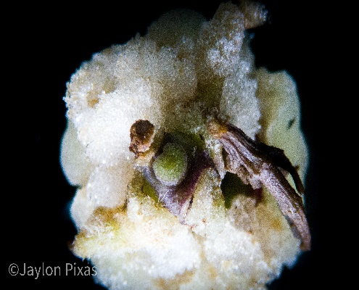 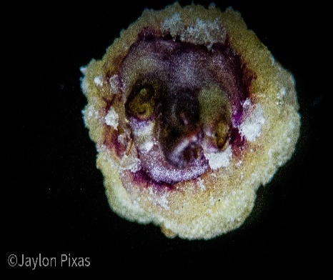

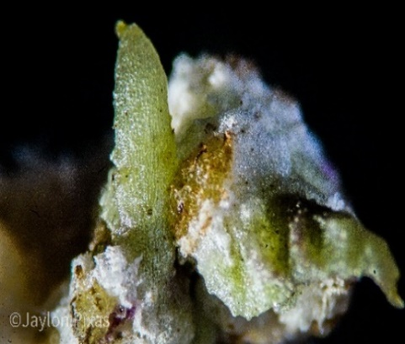 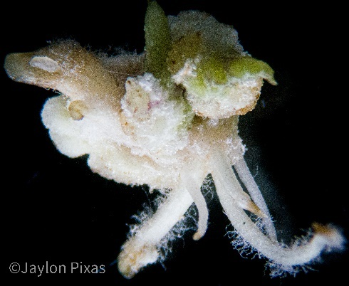 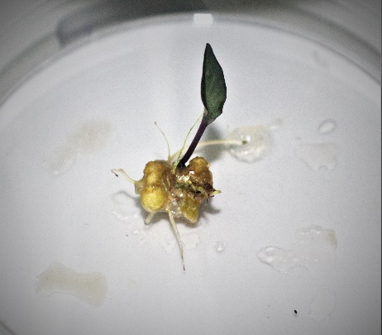

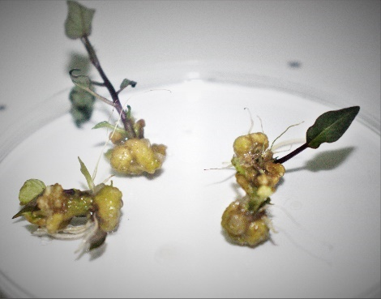 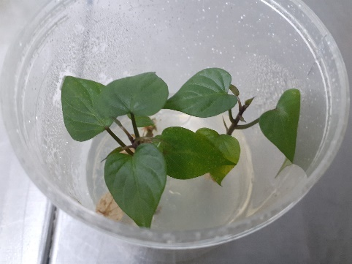 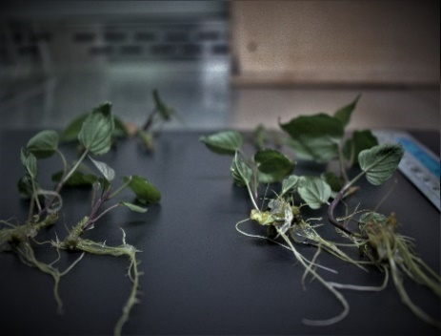

Schematic illustration of plant regeneration system for sweet potato (*Ipomoea batatas* Lam.) Gumine purple

**Milestone 3: Establishing invitro propagation protocol for banana through thorough invitro investigated experiments.**

* Further experiments were conducted on narrowing design points (PGR regimes) using plantlets regenerated from cycle 2, 3 & 4. Under this milestone, vitamin’s role were investigated especially myo-inositol; followed by ‘double bud’ and ‘single bud’ culture combine with optimum BAP level influences on multiplication rate. Myo-inositol role as an additive to enhance plant metabolism during multiplication phase is not significantly contributing to give such effects. We could not detect such effects during the short TC experiments and further provided window for further investigation. Diploid Kerua and Triploid Saina Mau did not show similar multiplication trend. Higher multiplication rates were obtained in Kerua using BAP level (6-8 mg/l BAP) with an average 20 shoots per explants, however, it took 6 weeks for proliferation. In comparison, triploid AAA require very low BAP level of 0.25 mg/l for multiplication. Higher BAP level (> 6mg/l BAP) decrease shoots and potentially increased stunted plants.
* Kerua showed clusters of shoots which resembled B genome, it is assumed that Kerua is not pure diploid rather a mixed diploid (AB) or triploid (ABB)

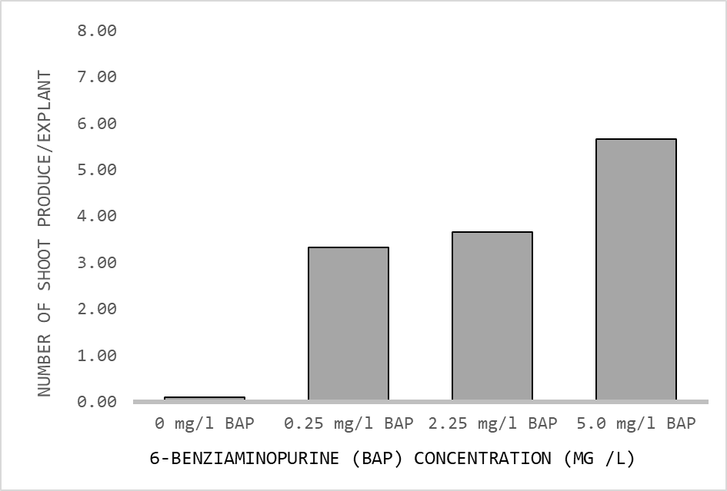 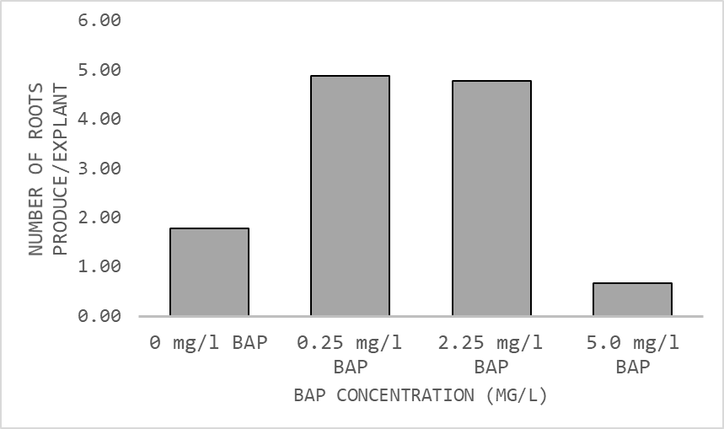

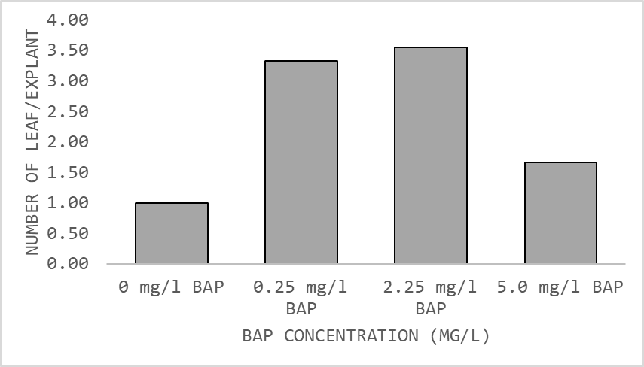 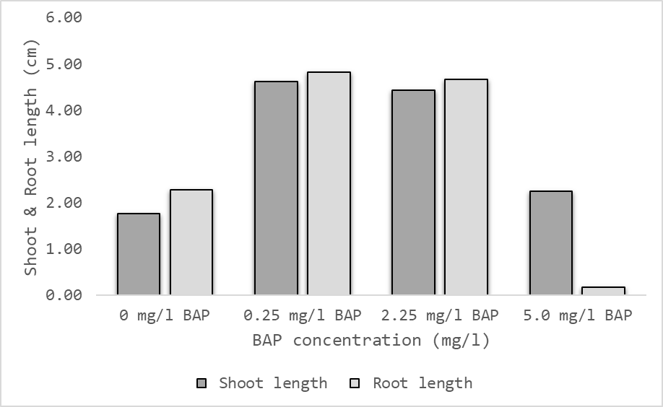

**Effect of BAP level on Local cavendish (Saina mau) invitro multiplication**

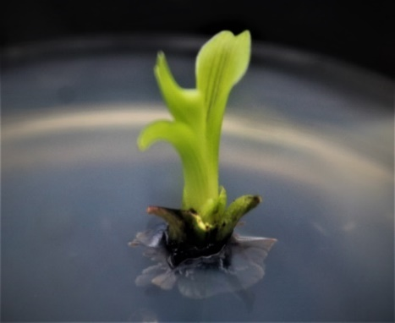 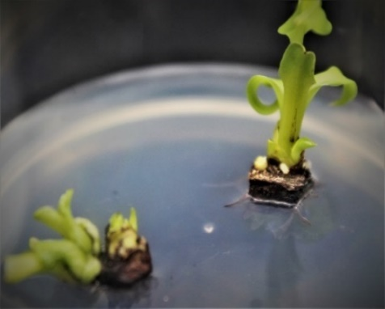 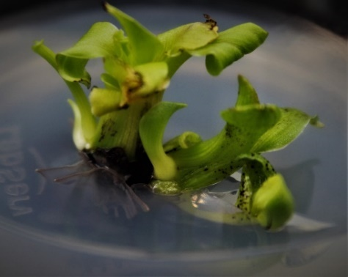

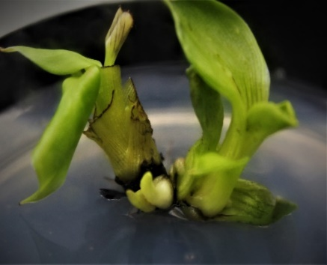 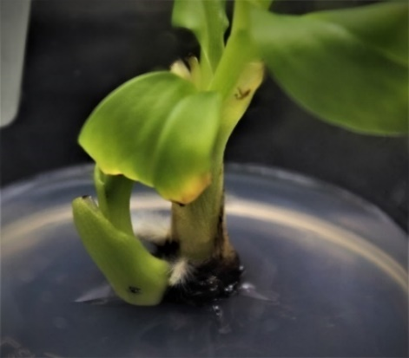 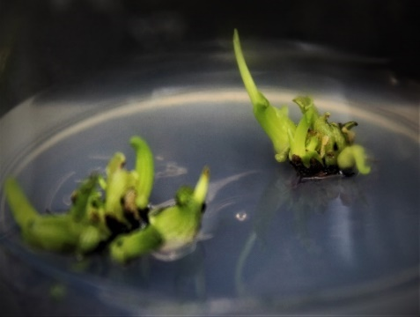

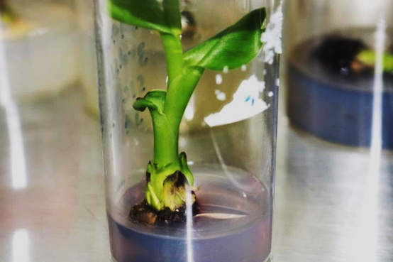 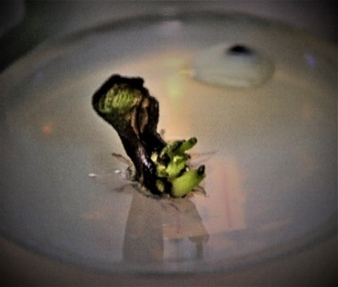 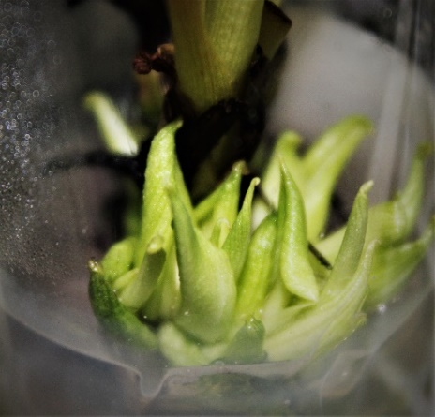

Kerua invitro propagation (a) Initiation (b & c) proliferation

.

**Milestone 4: Mass Multiplication of banana and sweet potato using derived established protocols from milestone 1 and 3 respectively.**

* The project emphasis with continued effort on mass multiplication of explants using developed protocol in the first quarter of 2022. More than 2000 plantlets have been achieved for Gumine purple sweet potato. The change in incorporating lowland sweet potato in the mutation breeding program is currently on target to reach 2000 in the month of May, 2022. However, the project activity pertaining to banana mass multiplication is being delayed due to several technical issues encounter during this phase. Improving multiplication rate in banana in the fourth cycle encountered shoot/leaf chlorosis which the project lost almost 23% of explants. A further delayed in investigating the cause of the chlorosis which finally was found and solved. Observatory results concluded several factors responsible for shoot chlorosis/ dieback symptoms’ which include (1) imbalance of cations and anions in the medium (2) Prolong sub-culture cycles more than 6 weeks (3) Incorrect Ratio between cytokinin and auxins applied. The project is anticipated to continued effort in increasing current explants of 410 to 2000 in the next cycles.

1. First Observatory experiments was designed to solve technical issues which include omitting of Amino acid such as Glycine in the medium. We noted that standard Glycine of 2mg/l cause chlorosis in local triploid (AAA) banana.
2. Second Observatory experiments was designed to quantify cycles duration which we concluded a maximum of 6 weeks is require to transfer to new medium but depends on the medium volume per vial.
3. 2

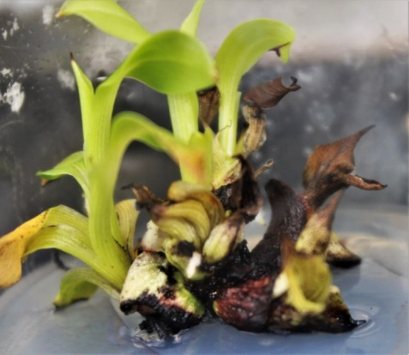 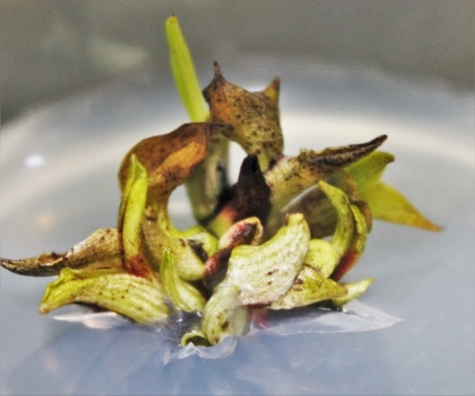 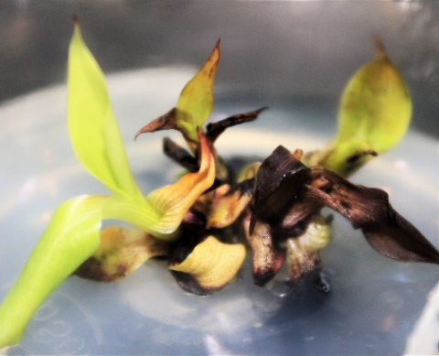

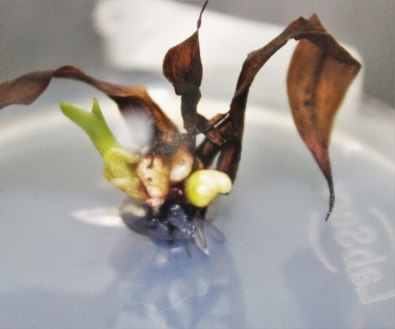 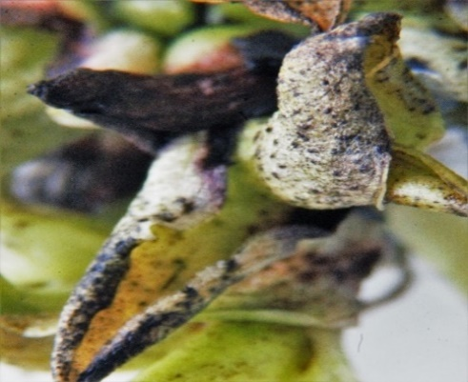 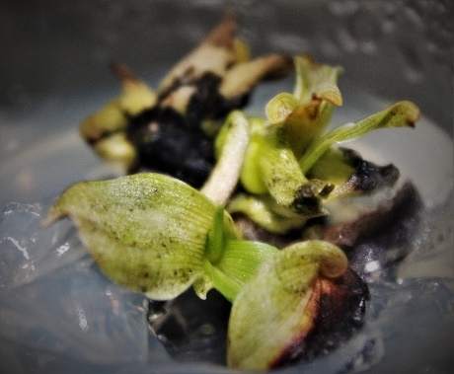

Types of chlorosis and dieback symptoms in banana invitro propagation

**Milestone 3.1. Standardizing of black sigatoka screening using detached leaf methods, invitro plantlets and nursery base screening.**

* No activities were conducted for this milestone under this reporting period. Two experiments conducted on developing anti-senescent media for banana detached leaf assays was concluded in December, 2021.

1. First experiment investigated the rate and wash duration of sodium hypochlorite on leaf chlorosis. Improper concentration and leaf wash time (LWT) causes Leaf chlorosis and affects the banana leaf senescent.
2. Second experiments investigated the effects of Plant growth hormones in sustaining the banana leaf color. Following optimized procedures form first experiments, results were obtained where Gibberellic Acid and Thiadizuron (TDZ) played significant role in sustaining leaf green color over three months period.
3. Third experiments did not eventuate in this reporting period but will be conducted in the next reporting period. Further investigation is needed to evaluate disease intensity using detached leaf.
4. Screening using invitro plantlets will be reported in the next reporting period.

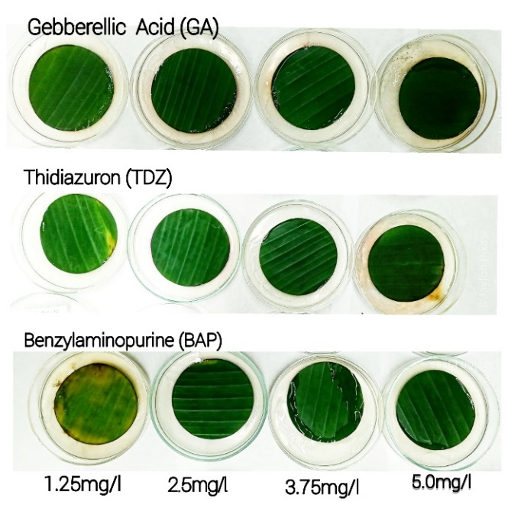 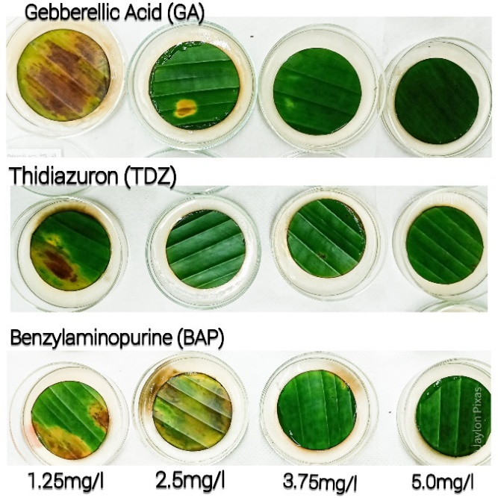

**B**

**D**

**Milestone 3.2. Optimizing protocol for sweet potato salinity screening using through tissue culture.**

* Under this milestone, project activities targeted invitro salinity screening for lowland sweet potato. Four lowland sweet potato (BSPBL 04, RAB 36, Simat and Chinese purple) were initiated and evaluated under salinity mediated stress. Highly extreme, moderate and low NaCl and control became the design points. Preliminary results showed that the sweet potato is susceptible to salinity stress. Invitro growth was very poor in BSPBL 04, RAB 36 and Chinese purple compare to Simat which can growth under moderate salinity stress. No sweet potato survived under 1.2% NaCl. It is anticipated that further design points (0-1.2% NaCl) is needed for further investigation with more cultivars. We proposed to applied 1.2% NaCl to screen mutants but may depends on next series of experiments which will be conducted the next phase.

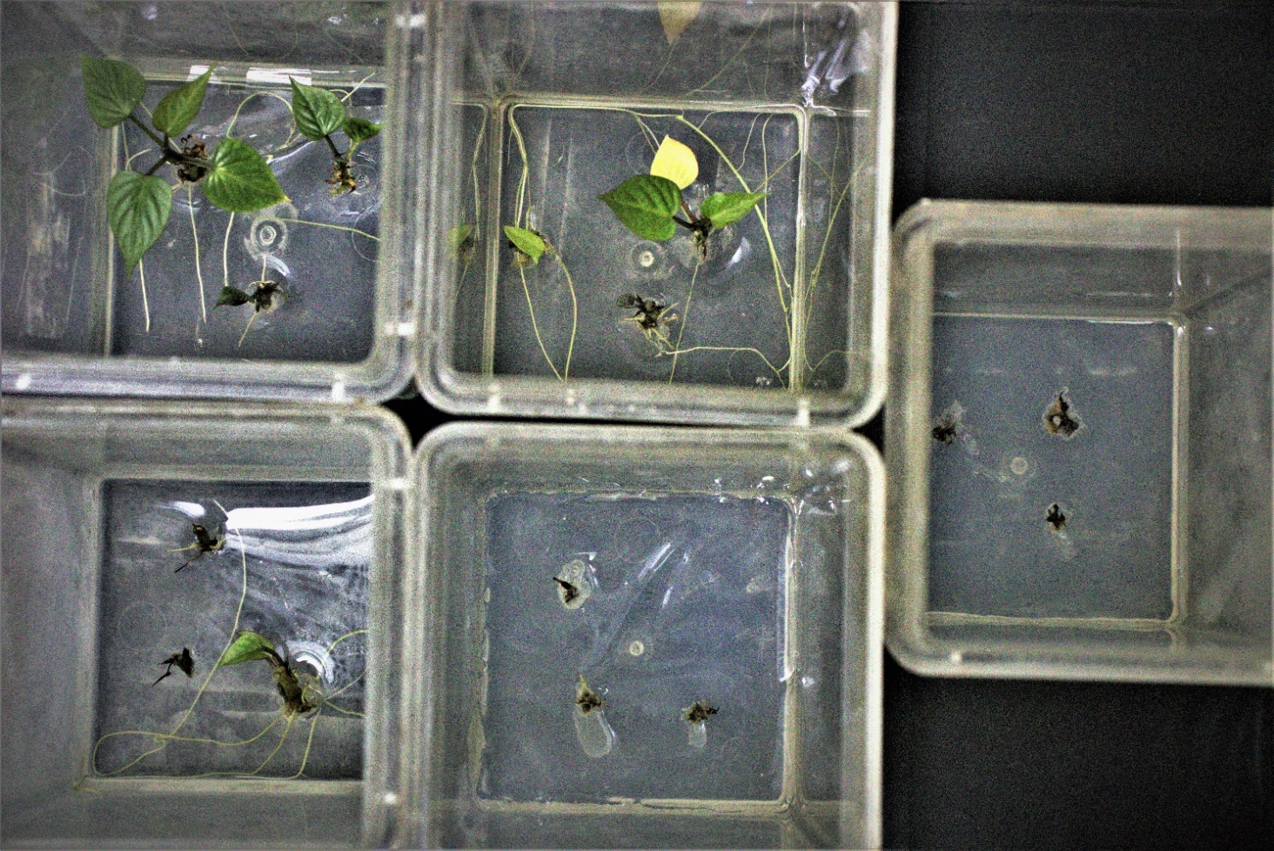

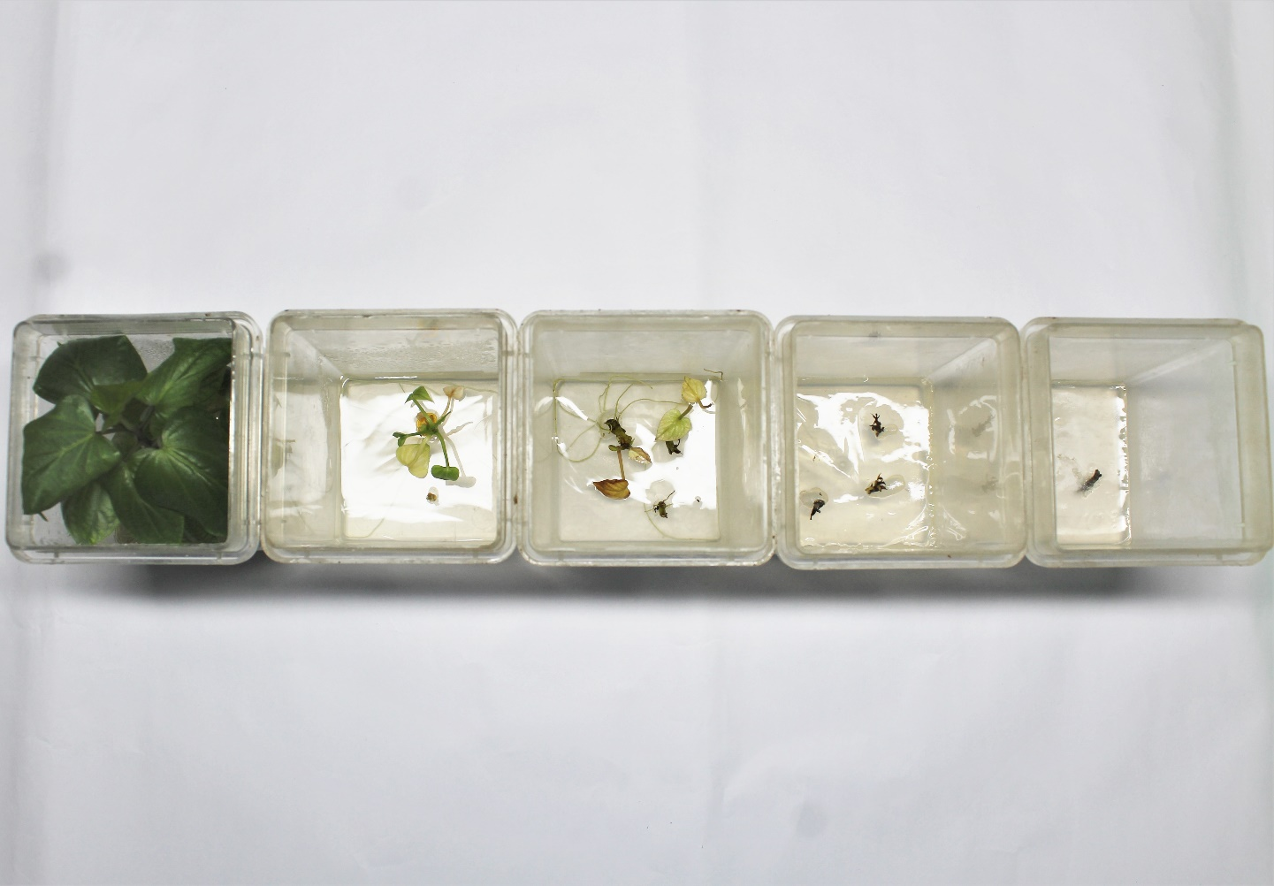

**Milestone 3.3. Optimizing protocol for sweet potato drought screening**

* No done on optimizing drought screening protocol. Screen house trial was recently investigated with 20 different cultivars and results will be available in the next reporting period. Moreover, we did not fully investigate the PEG in inducing invitro osmotic stress due to low molecular weights of PEG. We supposed to used PEG 6000 or 8000 but instead PEG 1400 was applied. The trial was terminated and planned for further investigation in the next period (May-June 2022)

1. **Progress towards the achievement of the planned outputs and Strategic Objective**

**Output 1- Resources mobilized through successful procurement and ensured breeding and screening facilities well maintained.**

* The project relied on materials procured under IAEA regional project on mutation breeding of vegetatively propagated crop (SAPI phase 2). The project output facilitates mobilization of resources base on in country activity needs. Progress made so far includes submission for procurement of screening equipment for 2022.
* Ensuring small facilities cater for mutation breeding and especially screening for associated stress is well maintained. Progress in this out seemed ongoing depending nature of the work.

**Output 2- Established efficient invitro propagation protocol for target banana and sweet potato and mass multiplied propagules.**

* Significant progress targeting optimizing banana and sweet potato invitro propagation, almost 80% completion under this output. The project main focus is towards mass multiplication of sweet potato and banana where 2000 plantlets have been multiplied for Gumine purple while 1100 for low land sweet potato.
* Banana mass multiplication faced technical issues on shoot/ leaf chlorosis and dieback symptom where 23% of banana were lost. However, issue was identified through investigated experiments and solved immediately.

**Output 3. Established efficient screening procedures/ protocol for salinity, drought, scab & black sigatoka**

* The project made progress into developing salinity screening using local sweet potato landraces. Critical NaCl designed points generated through kill curve. Further trials needed to validify the current data.
* Screening procedures for BSD is underway, progress already made on detached leaf method protocols while invitro plantlets in tubes and nursery base screening are pending.
* Drought and scab screening procedures will be conducted in the next reporting period.

1. **Explanation as to significant variances from timelines and implementation plans**

* Re-adjustment made on standard sweet potato medium
* Banana invitro multiplication is challenged by invitro shoot/leaf chlorosis and dieback symptoms which 23% of 524 explant was lost.
* Inclusion of another milestones and activities for salinity and droughts screening procedures.

1. **Modifications in the implementation plan impending problems and recommended solutions**

* Implementation plans was modified for the year 2022 (appendix 1) to cater for milestones set in for sweet potato invitro propagation protocol and screening procedures. Further modification on the incorporating chemical mutagenesis activities as one of the milestones set up for 2022.

1. **Lessons learnt or any other relevant observations as part of implementation**

Lesson learnt are:

1. Most sweet potato response well in standard multiplication medium while others need re-formulated of media.
2. The types of banana explants initiated contributed to its multiplication rate. It is both the genotypic effects and explant types used.
3. Although banana explants types contributed to its multiplication rate, those explants showing low multiplication rate can be improved by doing longitudinal cut from the shoot apex without completely split.
4. Long period of sub-culture contributed to lethality and chlorosis in banana
5. Adding amino acid (glycine) beyond 2mg/l slow growth of local dessert banana
6. We could not detect and find strike on effect on myo-inositol in proliferation. Myo-inositol from 30-100mg/l has similar effect on proliferation.
7. PEG should apply after media has been autoclaved by using infusion method. Direct application of PEG during media preparation inhibits nutrient absorption and translocation.
8. Responds of sweet potato to salinity stress depends on the number of nodes placed cut from one plantlet and placed in culture medium. Shoots tips responds differently from nodal culture.

6**. Provide a financial report for the period showing planned and actual expenditure per budget line.**

*Please provide copies of any relevant reports or other information completed during this reporting period as separate attachments* when you submit your report

|  |  |  |  |  |  |  |  |  |  |  |  |
| --- | --- | --- | --- | --- | --- | --- | --- | --- | --- | --- | --- |
| **REVISED B40235 Project Implementation Plan _Milestone and output indicators (10th January 2022)** | | | | | | | | | | | |
| **N°** | **Output/Milestone** | **Output Indicator relevant information to collect for milestones** | **Baseline needs** | **Date of achievement** | **% Completion** | **Responsible** | **2022 Q1** | **2022 Q2** | **2022 Q3** | **2022 Q4** |
| **Output 1** | **Resources mobilized through successful procurement and established** | OI 1: Materials needs identified as per mutation breeding activity and procured list generated. OI 2: Effectively mobilized resource as per project activity (Laboratory/Screen house) | Number of Equipment and tools supports laboratory activity. |  |  |  |  |  |  |  |
| Milestone 1 | Equipment and consumables need assessment and compilation of procurement list. | * Submission list made available as per IAEA budget. (SAPI phase 1 & 2) * Several Equipment and consumables received from IAEA to support in country breeding activity. |  | Ongoing |  | Joel, Gou, Jeffrey, Gure |  |  |  |  |
| Mile stone 2 | Maintenance of existing structure (green house nursery and propagator) for effectively conduct nursery base screening and acclimatization procedures. | * Existing structure maintained through resource mobilization from other related project activity. * Successful completion of nursery base activity with 2 x report compiled |  | ongoing |  | Joel, Gure & Jeffrey |  |  |  |  |
| **Output 2** | **Output 2- Established efficient invitro propagation protocol for target banana and sweet potato and mass multiplied propagules.** | OI 1: Target sweet potato and banana successfully propagated using defined protocols. OI 2: Invitro propagation technical issues identified and control measures applied along each stage and documented. | Invitro propagation protocol documented and used as working protocol for particular sweet potato and banana |  |  |  |  |  |  |  |
| Milestone 1 | Establishing invitro propagation protocol for sweet potato through thorough invitro investigated experiments. | Technical report detailing: Initiation, Multiplication, Rooting & Acclimatization. Revised protocol effectively outperformed standard SP multiplication medium |  |  | 95% | Joel, Alwin & Juliar |  |  |  |  |
| Milestone 2 | Establishing callus mediate protocol for sweet potato |  |  |  |  | Joel & Julia |  |  |  |  |
| Milestone 3 | Establishing invitro propagation protocol for banana through thorough invitro investigated experiments. | * Surface sterilization design points developed. * Banana initiation, multiplication, rooting and Acclimatization protocol developed with sufficient data for validation. * |  |  | 95% | Joel, Alwin & Juliar |  |  |  |  |
| Milestone 4 | Mass Multiplication of banana and sweet potato using derived established protcols from M1 and M2 respectively | *2000 sweet potato explant per variety produced. *2000 banana explants produced |  |  | 50% | Julia, Janiella, Elijah & Joel |  |  |  |  |
| **Output 3** | **Established efficient screening procedures/ protocol for salinity, drought, scab & black sigatoka** | OI 1: Efficient disease screening procedures adopted, evaluated and redefined to suits local condition with appropriated experimental data OI 2: Screening design points for associated stress defined with validated experimental data. OI 3: Equipment calibrated and tested for efficient screening; Calibrated manual generated for lab use. | Efficient screening protocol documented and used as working protocol for screening associated stress (Scab, BSD, salinity and drought) |  |  |  |  |  |  |  |
| Milestone 1 | Standardizing of black sigatoka screening using detached leaf methods, invitro plantlets and nursery base screening. | *Number of optimized experiments conducted. (Leaf chlorosis data, Anti-senescent data). *Assessment of disease symptoms and severity and generation of disease index. |  |  | 50% | Janiella, Joel & Gou |  |  |  |  |
| Milestone 2 | Optimizing protocol for sweet potato salinity screening using through tissue culture. | * Four sweet potato variety tested and evaluated under invitro mediated NaCl stress condition. * At least more 20 sweet potato cultivars evaluated under salinity stress under screen house condition. *NaCl design points developed *Protocols and Technical report detailed. |  |  | 100% | Alwin & Joel |  |  |  |  |
| Milestone3 | Optimizing protocol for sweet potato drought screening | * Four sweet potato variety tested and evaluated under invitro mediated PEG 6000 stress conditions. * At least more 20 sweet potato cultivars evaluated under drought stress under screen house condition. *PEG 6000 design points developed * Protocols and Technical report detailed. |  |  | 40% | Laurance, Cecily, Janiella & Joel |  |  |  |  |
| Milestone 4 | Optimizing protocol for sweet potato scab | *At least more 20 sweet potato cultivars evaluated under scab intense stress under screen house and field condition. *Fungal LD's points developed * Protocols and Technical report detailed. |  |  | 20% | Julia & Joel |  |  |  |  |
| **Output 3** | **Output 4- Invitro Plantlets radiated and screened for associated stesses.** | OI 1: Target sweet potato and banana successfully radiated at nearby radiation facilities with at least 3-4 different Gamma dosage with good recovery rate. OI 2: Invitro sub-culture conducted for at least 4 generation for chimerism removal. OI 3. Sweet potato and banana screened for associated stress with at least one mutant identified. |  |  |  |  |  |  |  |  |
| Milestone 1 | Irradiation of sweet potato and Banana | * Two sweet potato varieties irradiated using Gama Radiation at Seibesdolf or Batan *Two banana cultivars irradiated using Gama Radiation at seibersdolf (Austria) or Batan (Indonesia) or in Malasia |  |  |  | Joel |  |  |  |  |
| Milestone 2 | Application of EMS for mutation induction in sweet potato & Banana | * at least 250 sweet potato and banana explant subjected to EMS treatments and four subculture obtained * LD 50 EMS dosage generated (kill curve established) for sweet potato and banana |  |  |  | Joel & Jeffrey |  |  |  |  |
| Milestone 3 | Sweet Potato Scab screening and selection of putative mutants in M1V2, M1V3 population | * Over 1000 plantlets multiplied invitro for scab tolerance screening under screen house condition using defined protocols for scab screening. *Over 1000 plants assembled for screening under screen house. * Apply scab selection presure and obtain one mutant for further multiplication and evaluation * Gamma radiation dosage identified to obtain |  |  |  | Joel, Janiella, & Julia |  |  |  |  |
| Milestone 4 | Invitro and screen house Salinity screening of sweet potato using critical NaCl design points. | * Over 1000 plantlets multiplied invitro for salinity tolerance screening using defined protocols for salinity screening. * Stress selection point applied and one salinity mutant identified along the generative sub-culture cycles. |  |  |  | Joel, Janiella, & Julia |  |  |  |  |
| Milestone 5 | Invitro and screen house drought screening of sweet potato using critical PEG 6000 design points and Wilting Index for survival under early soil moisture deficit condition respectively. | * Over 1000 plantlets multiplied invitro for drought tolerance screening using defined protocols for drought screening. * Stress selection point applied and one drought tolerant mutant identified along the generative sub-culture cycles. |  |  |  | Joel, Janiella, & Julia |  |  |  |  |
| Milestone 6 | Elite SP and banana lines further evaluated on field | * At least mutants identified through selection presure under screen house condition subjected to field evaluation (yield, level of tolerance identified). * Scab, BSD and drought tolerance evaluated using design experimental protocol |  |  |  | TBA |  |  |  |  |